Wetland Site
Vehicle Access

Car parks:
The Leys, Ballards Road
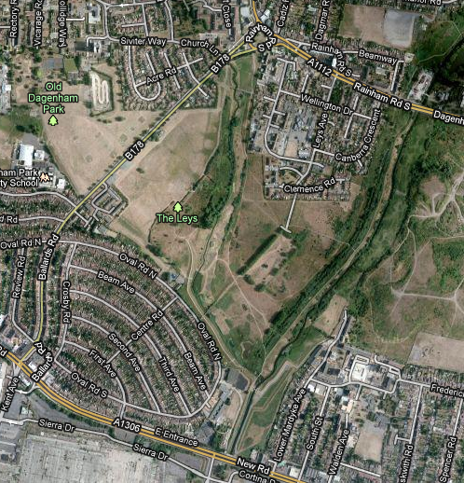
Meeting point (no vehicle Access):
Leys Car Park, Ballards Road. RM10 9QH.

Vehicle Access points:
Adjacent to Leys Car Park (as above)

Nearest Tube station: Dagenham East, approx. 800m north of site, along Rainham Road South.

Wetland site: The Leys (park)

Contact: Irene, Whale of a Time Workshop 07903 207725

